Quick Start Guide: Page on installation and usage option provide details to setup project and use streamlit as well as CLI. In order to access streamlit app from running docker container, use log section and Local URL

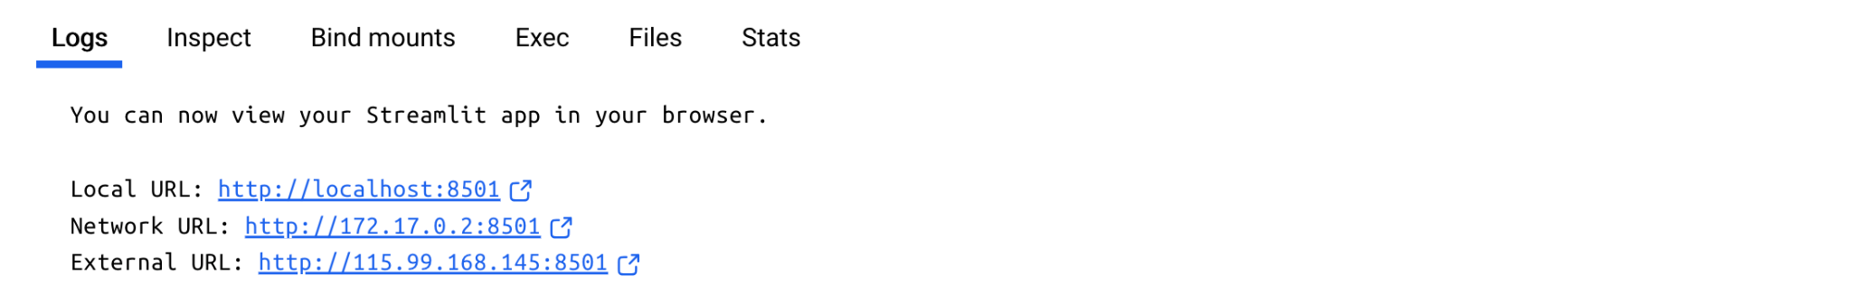

Results from Steamlit App:

AI Factory Growth Ranker: Json file has data for 50 companies. Company Analysis can be performed for each individual company by selecting Analysis Tab, and a company for analysis at a time.

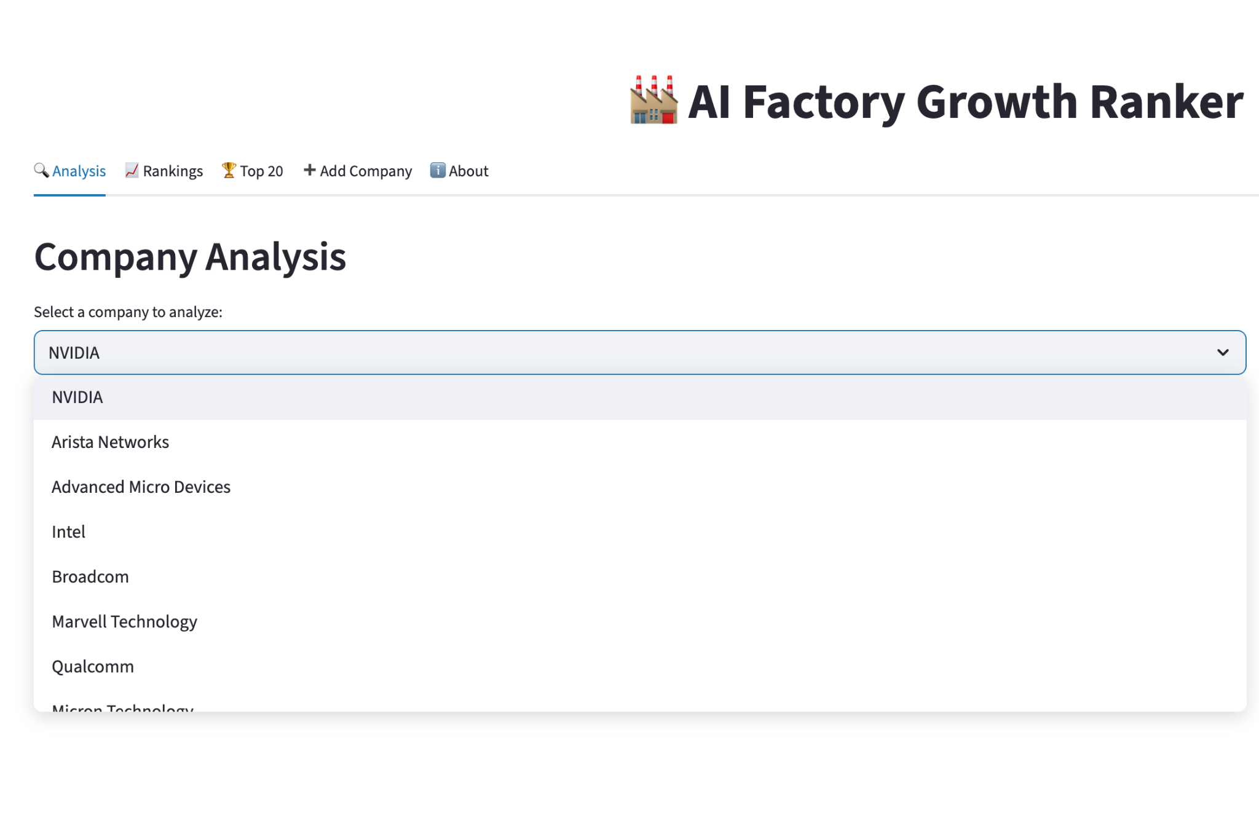

Analysis for company Intel:

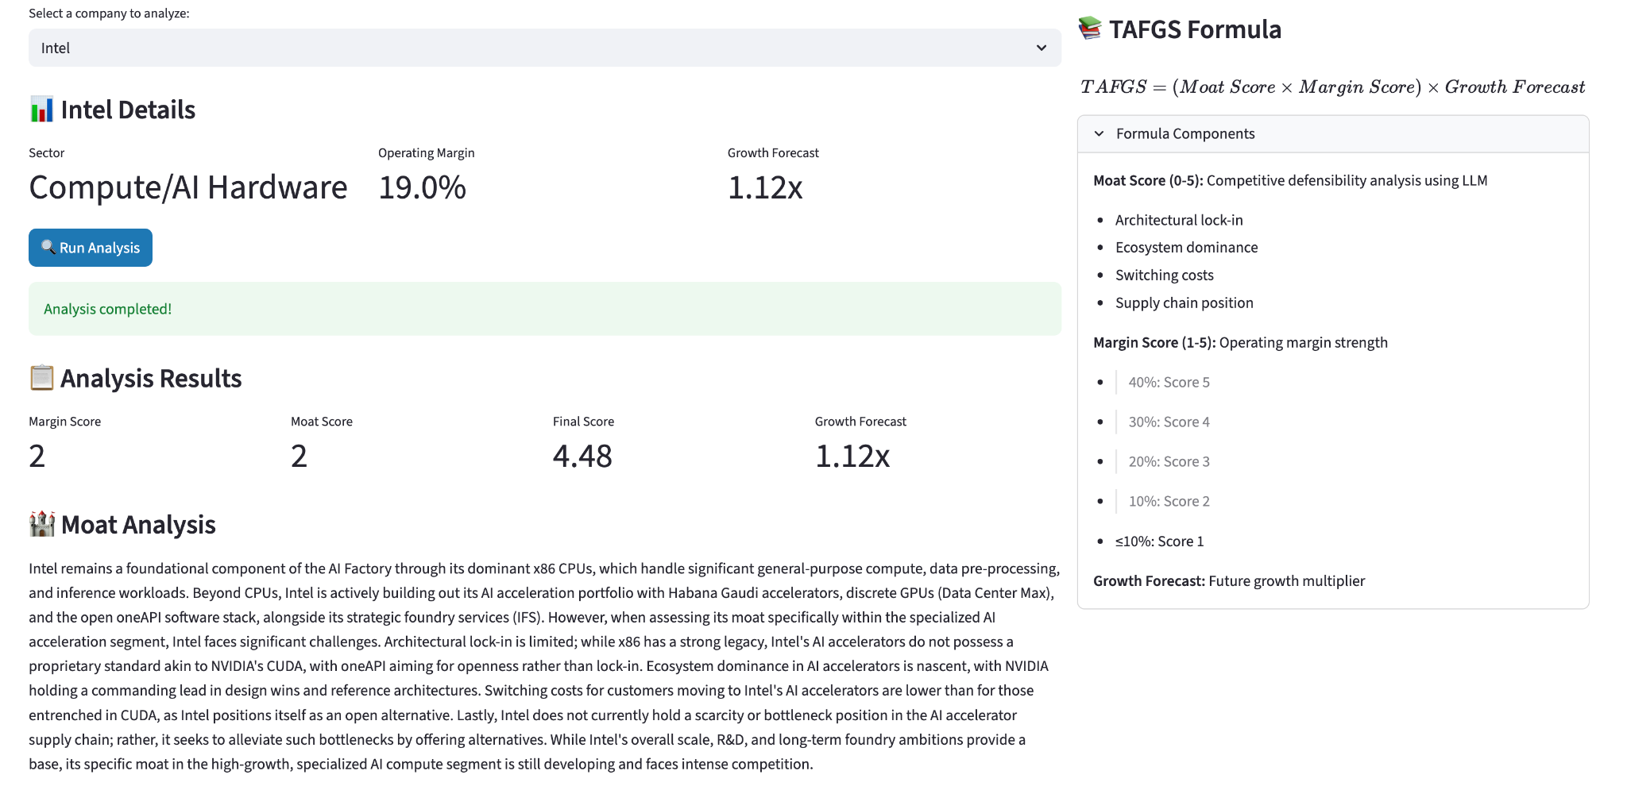

TAFGS Formula detail is provided to the user along with the framework to get analysis for an individual company.

Ranking Tab, provides a framework to rank companies.

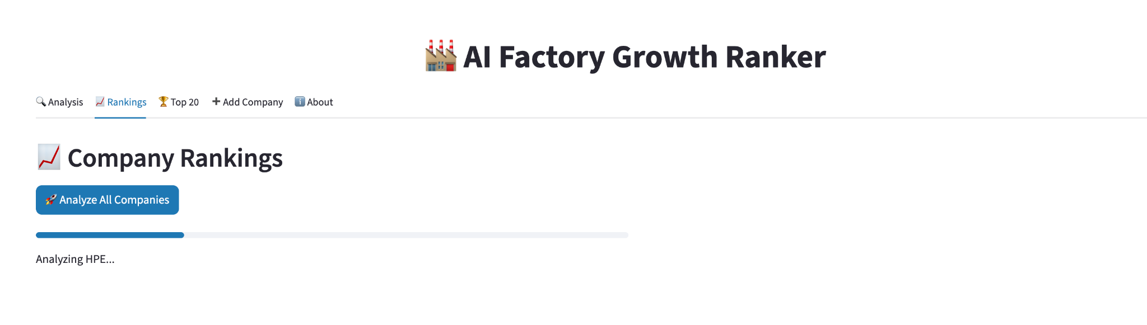

Top 20 Tab, provide features to get top 20 companies as well sector specific analysis.

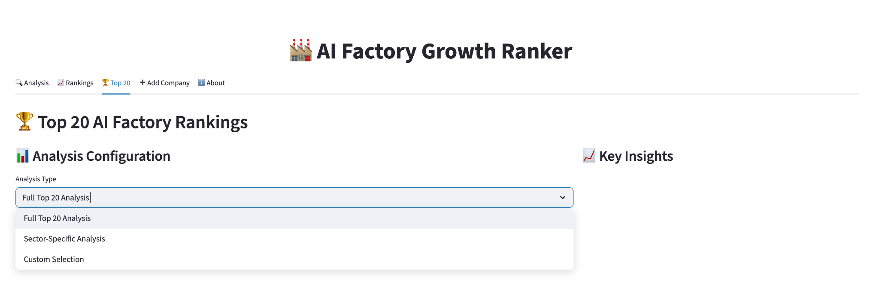

Add company Tab, provide features to add a company. (the feature is under development)

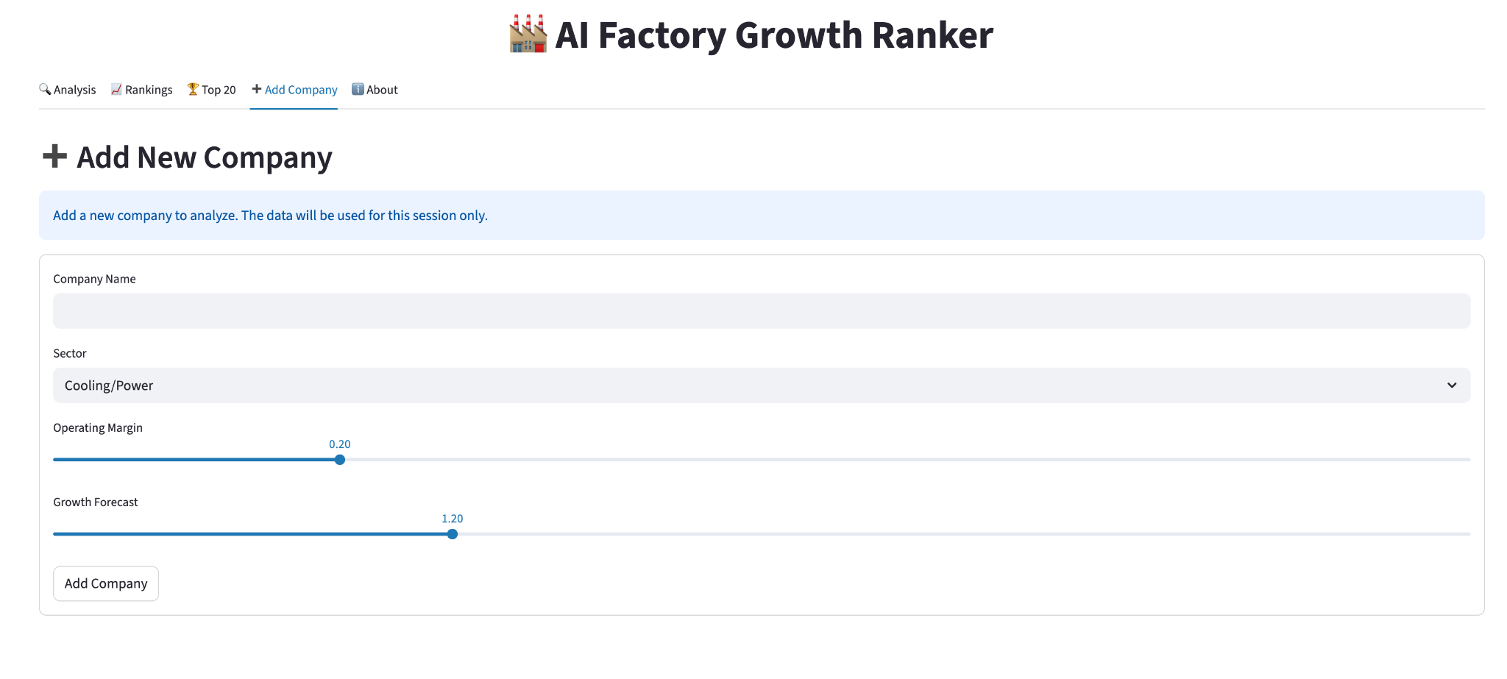

About Tab, provide features to the user to get details on different concepts.

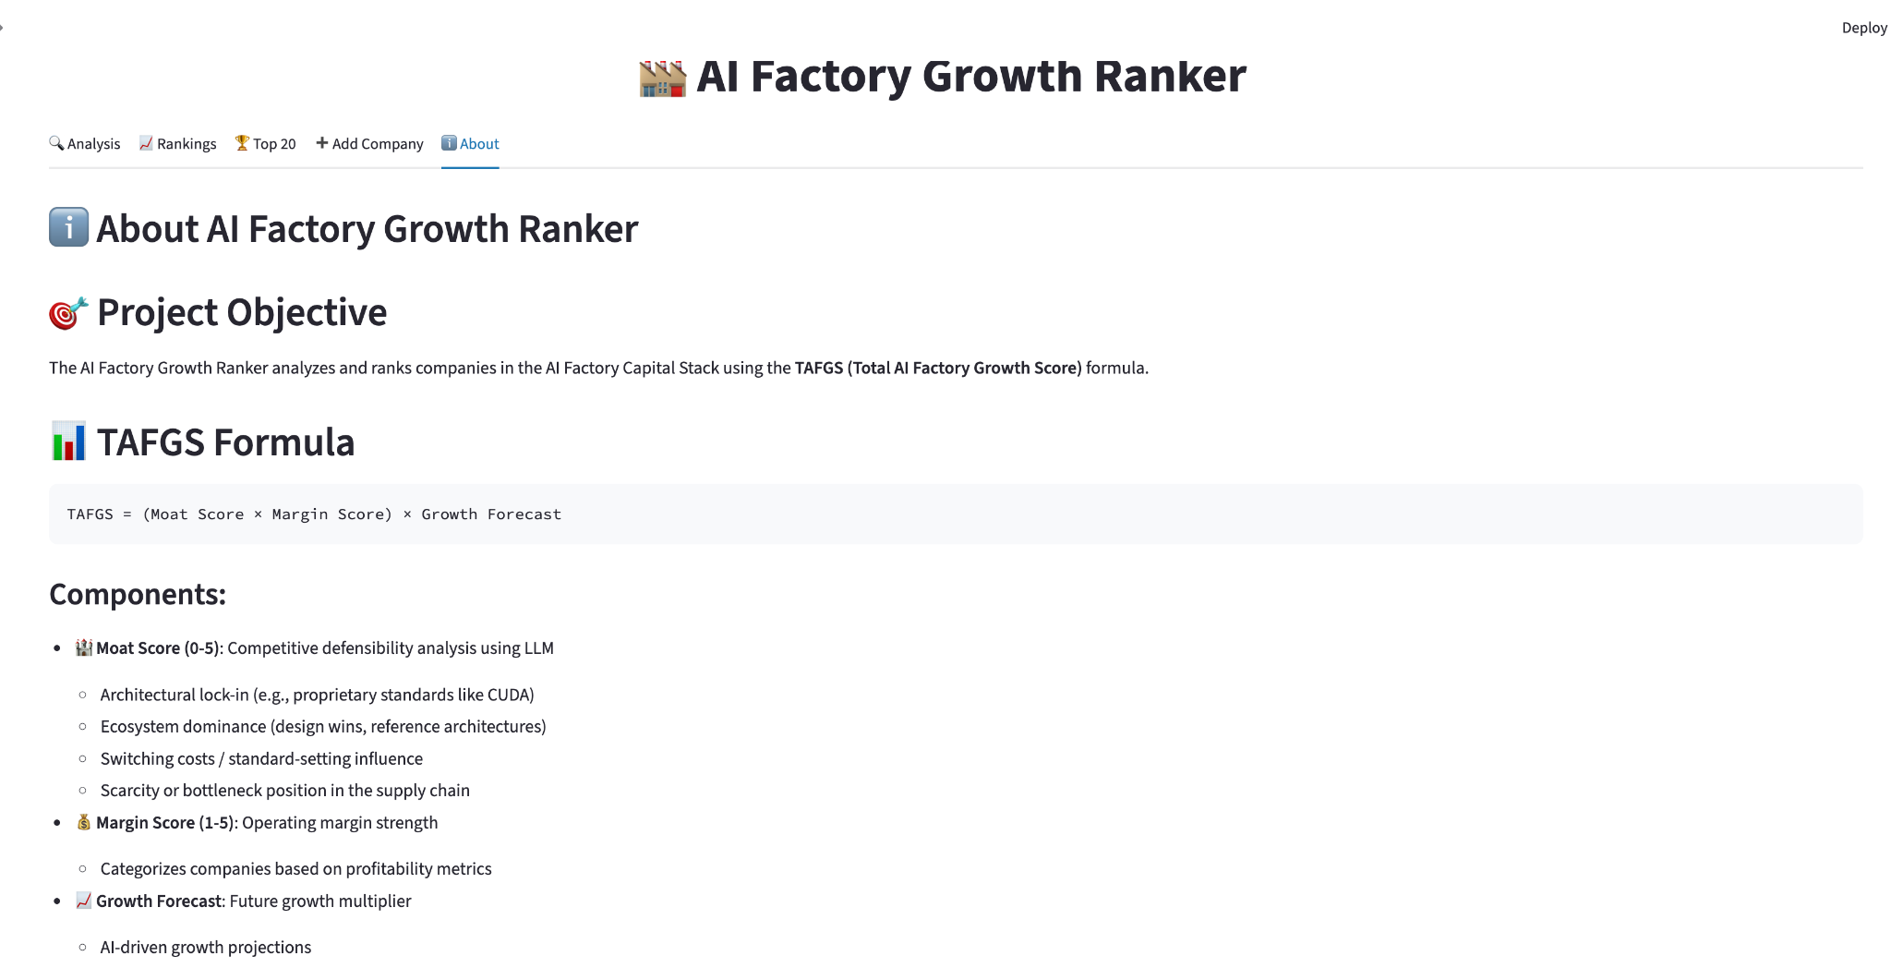

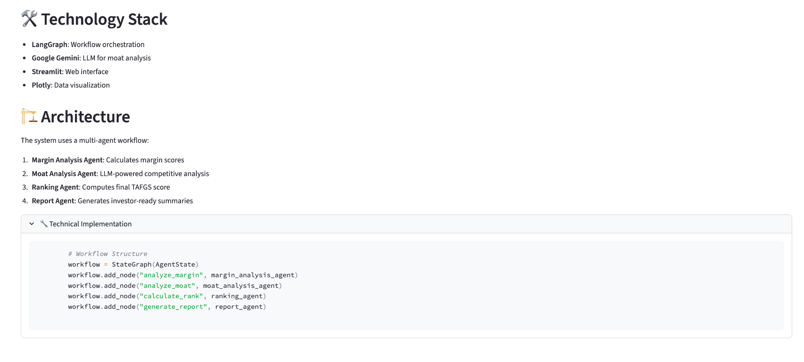

Because of Google API quota exhaustion for running analysis on all companies, results are not being produced out of 50 companies.

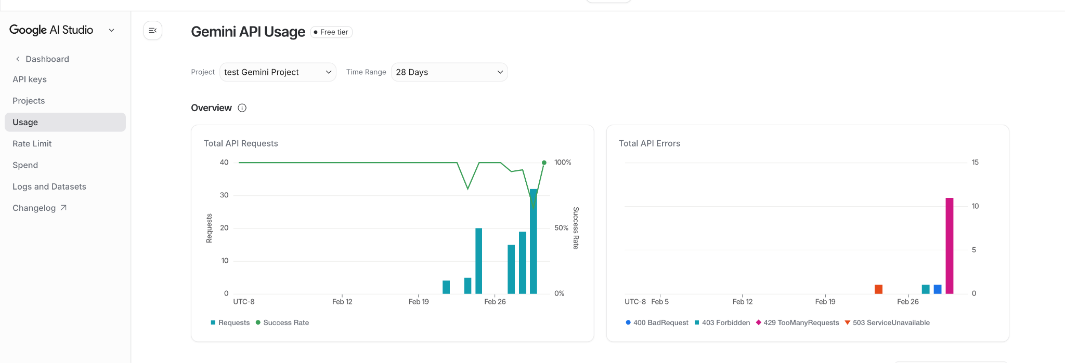

Top20 companies can be achieved using Top20 Tab.

